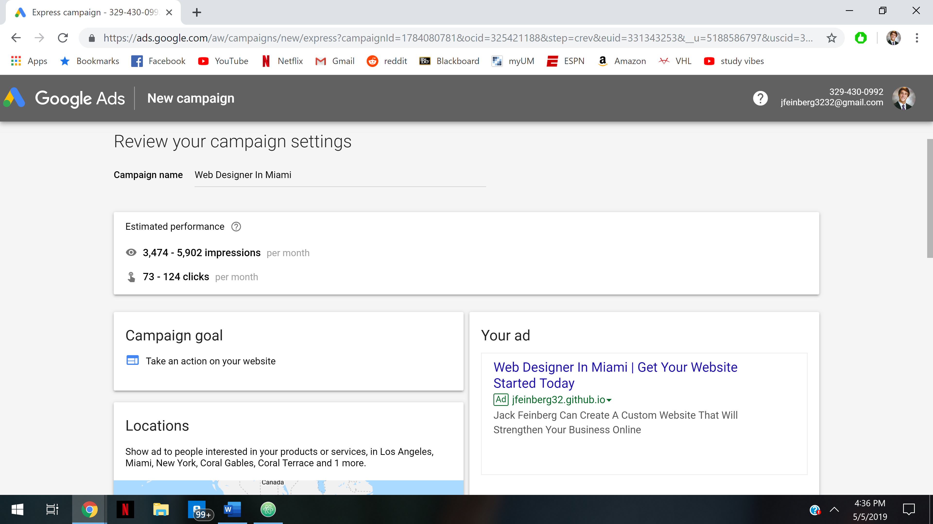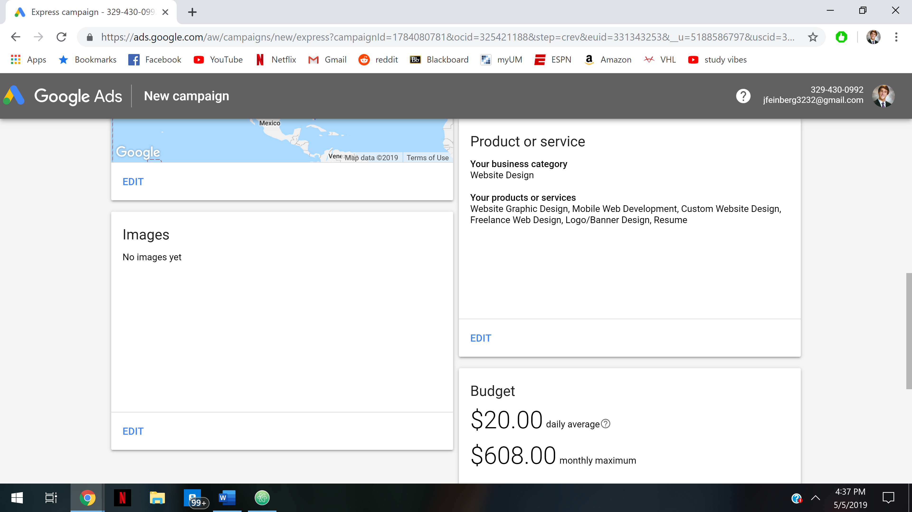

The typical competitor budget ranges from about $9-50. Therefore, I decided to select a daily average of $20, so it is slightly around the middle of the range, but a little bit under due to my business being new and not likely to be highly profitable at first. Therefore, once I start getting more profits, I can slowly increase my exposures. Additionally, since right now it would only be me working on projects, I won’t be able to take in a high volume of projects since I need to be able to develop a high-quality of work.

I will be using the keywords as listed in the screenshot as they are all related to the business of web development and should steer people looking to get a presence on the web towards me. Additionally, they are diverse enough so that people on the web might not be searching exactly for a web developer but could stumble upon my website accidentally and decide to look deeper.

I hope to not have to run the ads for more than a few months, until my potential web developer business would gain popularity and hopefully have enough work to the point where it would act on itself as advertisements.

With about 700-1400 impressions a week, I should hopefully get at least 1-2 inquires during that time, which I believe should be a good starting pace of projects.